Ventnor Developer Has Big Plans for Wellington Ave Shopping Plaza
Leave a Comment / October 2, 2022
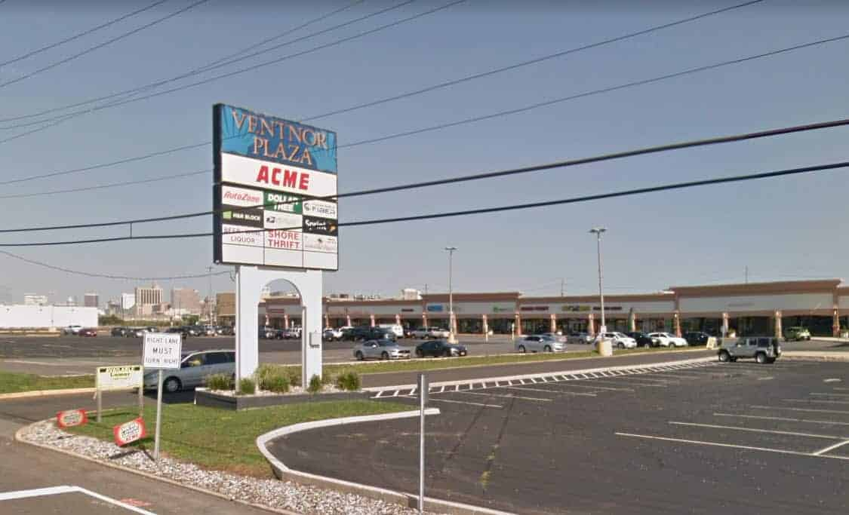
After years of semi-neglect, Ventnor Plaza has a new owner. A new lease on life too.
According to the Press of Atlantic City, the 15 acre retail parcel on Wellington Ave in Ventnor was sold this past June.
A group of investors lead by Real Estate developer and Ventnor resident Mark Greco acquired the property from LAMAR Management.
Ventnor Plaza features popular anchor businesses that include ACME, Auto Zone, the US Post Office and Island Gym.

Mark L. Greco
Real Estate Acquisition, Development, Leasing, Property Management
Visit MLG Realty
Even with strong tenants like ACME, the Plaza still suffers from empty retail units. Approx 40% vacancy rate. Greco aims to fix that problem.
Good news on the way. Much needed facelift coming. In the near term, look for a repaved parking lot, nicer landscaping and better lighting.
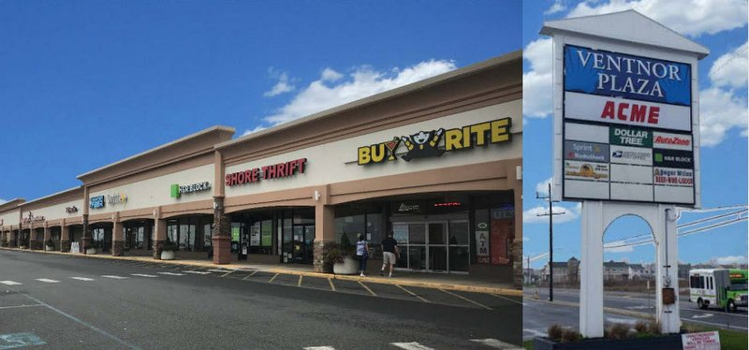
A Ventnor gateway location. One of the entrance ways to Ventnor City. Must enhance visual appeal. Make good impression.
New owner plans to revive this shopping destination on Wellington Ave in Ventnor.
According to the Press of Atlantic City, we might see a new restaurant, a fast food option, and electric car charging stations.
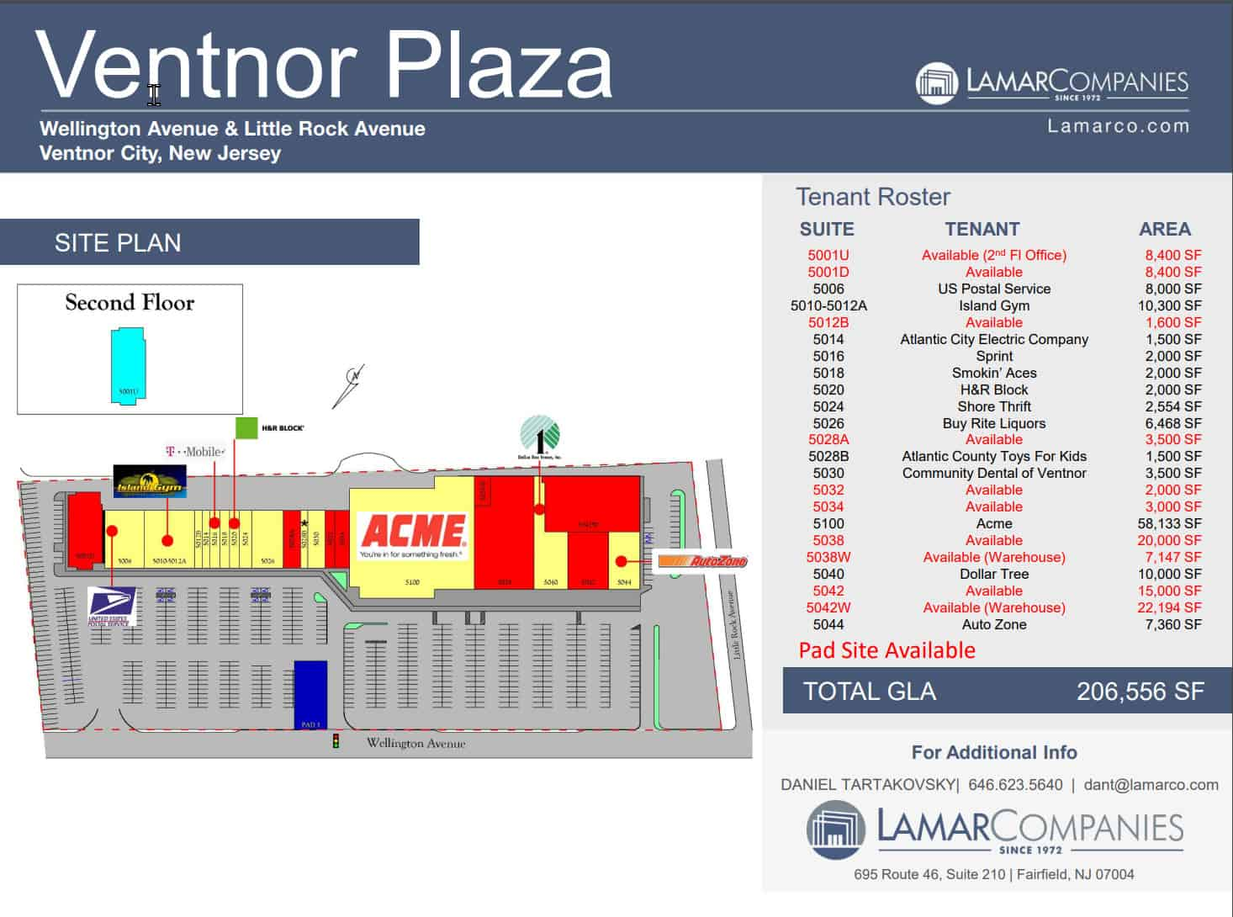
MLG Realty provides retail and office space in South Jersey.
Mark L. Greco founded MLG Realty in 1994, purchasing his first of many residential rental properties at the Jersey shore. Mark branched into commercial property with his first shopping center purchase in 1999.
MLG Realty owns several, South Jersey shopping centers.
MLG Realty expertise includes: site selection, acquisition, renovation, and leasing of shopping centers, professional office suites, and other commercial developments.

